Computer Science II
Shon Hakanson
9/24/2025
Perudo Clone Video Game

Description:
My Perudo Clone project has been a personal coding project whose purpose is to recreate a clone of the board game called “Perudo”, using assistance from ChatGPT to help navigate the complexities of multimedia libraries and unfamiliar coding languages. The game involves betting how many of a certain dice face are being held by the players involved, and calling bluffs to cause other players to lose their dice. My version will be a 2D video game that possesses the same rules as regular Perudo.
Features:
The main features of the 2D video game version of Perudo that I have been attempting to make are a functioning display window with graphics for the dice and cups involved in the game, local online multiplayer to prevent players from having to see their opponents hands, a functional HUD, and an in-window button system to simplify controls and eliminate confusing keyboard inputs.
Tools:
The tools that that have been used on this project are the C++ coding language, the SFML multimedia library, Visual Studio, and Cmake. SFML is a multimedia library for coding games that holds different classes, functions and other things to call on in order to simplify the process of making things like display windows, buttons, sprites, or other things. Cmake is a software that works with Visual Studios to create new projects and builds based off of a specific .txt file instead of the normal VS project creation process. It allows you to specify usages of other files and what executables are desired inside the .txt file, and create new builds of your project based off any desired result from the .txt file.

Flowchart:
(The following flowchart was built with the assistance of ChatGPT, as this large language model was instrumental in creating the Perudo clone.)

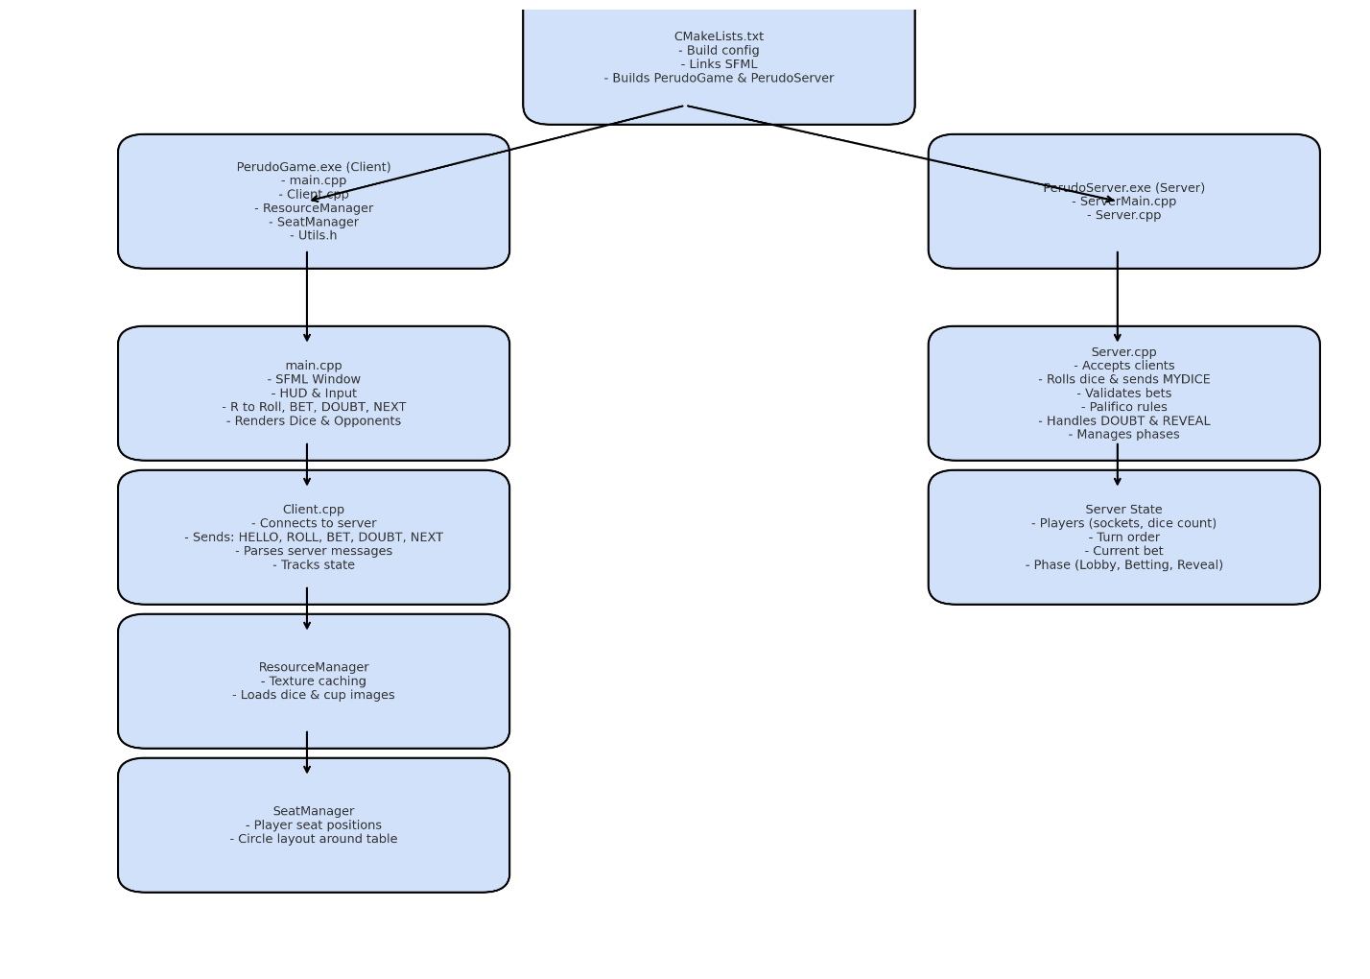
Milestones/Progress Tracker:
- Project Setup
- Use CMakeList text file and Visual Studio to generate project and assorted files/executables that are linked automatically with SFML files for networking, graphics, etc.
- Basic Graphics
- Implement display window with free use dice and cup images displayed properly on screen, as well as implement shuffle and shuffle animation to randomly change dice and show the dice faces changing.
- Adding Multiple Players
- Implementing graphics in such a way that multiple people can be shown, with other players’ dice replaced by a cup.
- Implementing Networking Capabilities
- Diverging files system from a single main file into a main file for certain graphic’s and gameplay implementations, a server file to create server port handle gameplay issues, like phases of play, rounds, separate players, dice shuffling timing, messages, and connection errors, as well as creating a client file that connects to the server port, handles the player’s inputs and sends them to the server to accomplish basic gameplay tasks. Other files were also created to assist in these tasks but end up linking back to these main roles. Header files were also created to create the classes that the .cpp files methodize and use to work the game.
- Implement Online Gameplay Loop
- Using rules of Perudo as a baseline, get shuffling mechanics, graphics, and animations functioning between server and client, get gameplay rules implemented on Server and Client, and get HUD/Input system working to begin testing game functions.
- Debug Gameplay and Graphics
- Once a game is finally somewhat playable, begin to polish lacking aspects (inelegant input systems, HUD inaccuracies, missing HUD elements, graphical bugs, breaks in gameplay rules) to ensure player’s gameplay proceeds as a normal Perudo game would.
- Merge Project File Into One Executable
- Take all the files that make the project work, and merge them together into one application that will do everything without the hassle of navigating the current folder setup.

